**Education Health Care Plan Annual Review Guidance**

**and**

**Practice Standards**

This guidance has been developed drawing on the following legal framework:

* The Children and Families Act 2014.
* The special educational needs and disability regulations 2014, specifically regulations 18 to 21.
* The Special educational needs and disability code of practice: 0 to 25 years, Department of Education and Department of Health, January 2015, paragraphs 9.166 to 9.185 and p 9.173

*As part of the review, the local authority and the school, further education college or Section 41 approved institution attended by the child or young person****must****co-operate to ensure a review meeting takes place.*

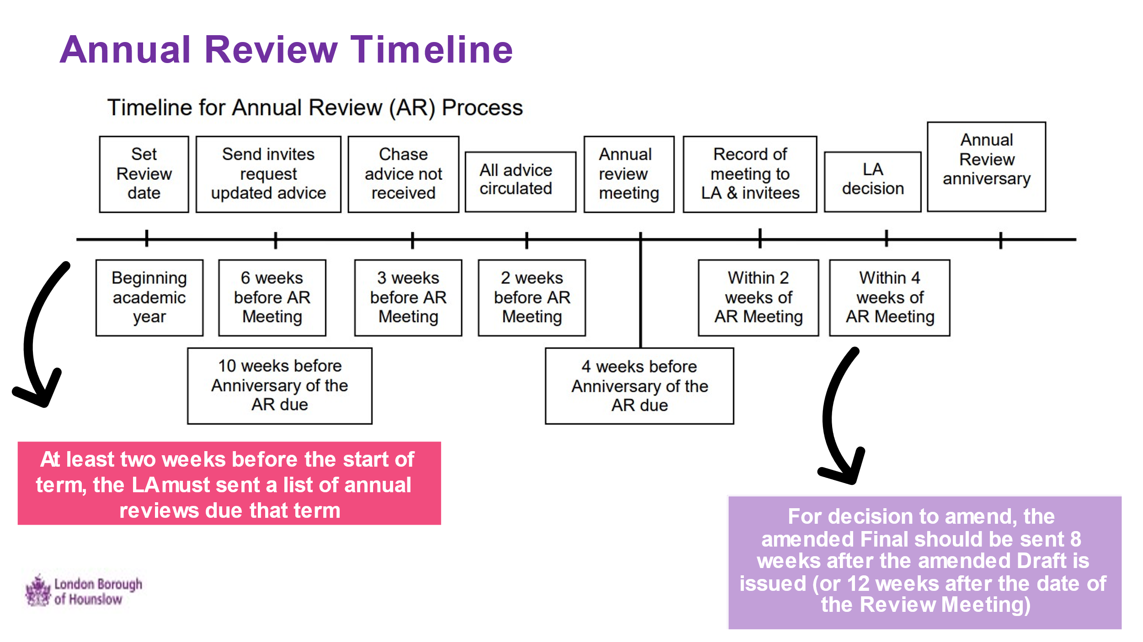

**Statutory timeframes and responsibilities**

The Annual Review **process** is more than just a review meeting, it is the whole process from setting the meeting, holding the meeting and the local authority’s decision that **must** be completed on or before the anniversary of when the EHC PLAN was first issued, or the anniversary of the last review meeting. As part of a review of a child or young person’s EHC Plan, the local authority must ensure that a meeting to review that EHC Plan is held by the education setting attended by the child or young person.

The following persons must be invited to attend the review meeting:

* the child’s parent or the young person.
* the provider of the relevant early years’ education or the head teacher or principal of the school, post-16 or other institution attended by the child or young person;
* an officer of the authority who exercises the local authority’s education functions in relation to children and young people with special educational needs.
* a health care professional identified by the responsible commissioning body to provide advice about health care provision in relation to the child or young person;
* an officer of the authority who exercises the local authority’s social services functions in relation to children and young people with special educational needs For looked after children (LAC), the review of the personal education Plans (PEP) should be integrated into the annual review.
* Education Setting – Careers Advisor for pupil in year 10 and 11.

**The following practice standards must be adhered to when reviewing EHC Plan:**

**Before the annual review meeting**

* Education settings to gather updated advice and reports giving at least 6 weeks’ notice to the advice givers.
* Ensure parents carers and professionals are invited to attend the meeting with at least 2 weeks’ notice. Annual reviews meeting should include relevant people supporting the CYP as well as anyone parent carers or the young person wants at the meeting.
* Ensure everyone attending have had copies of the current EHC Plan and reports shared at least 2 weeks prior to the meeting.
* Prepare the child or young person so that they can contribute to their review during the meeting.
* Ensure parents carers, children and young peoples are supported to feel confident to contribute and give their views, allow sufficient time. Parents to be signposted to Hounslow’s Information, Advice and Support Service (SENDIASS) on 020 8583 2607 or email SENDIASS@hounslow.gov.uk. This service is free to parents/carers of children with special educational needs (SEN) or a disability.

It is helpful to have an agenda that guides the annual review meeting. A suggested agenda is provided (EHC Annual Review Guidance Agenda).

**During the meeting**

* Ensure everyone has a copy of the agenda and paperwork. Clarify meeting purpose and create a collaborative and supportive atmosphere.
* Children, parents’ carers and young people should be at the centre of the review and must take account of their views using person centred approaches.
* Identify and celebrate the child or young person’s progress.
* Ensure everyone in attendance has an opportunity to contribute.
* Check all basic information on the CYP and family, record any changes.
* Ensure every section of the EHC Plan is checked and identify changes needed.
* Evaluate the continued effectiveness and relevance of the provision set out in the EHC Plan so that a recommendation can be made to the Local Authority. EHC Plans are not expected to require frequent changes and updates (CoP 9.193). When they do need amending, there should be supporting evidence to inform any changes).
* Ensure everyone promotes and plans for the child and young person’s preparation for adulthood (PfA) aspects at the earliest time however, particularly from Y9 onwards.
* Consideration and recommendations provided as to whether it is necessary to continue to maintain the EHC Plan as it is, request amendment, re-assessment or cessation of the EHC Plan.
* Give families and the C/YP the opportunity to request a Personal Budget and review the effectiveness of any Personal Budgets already in place.
* Where the child or young person receives support with travel assistant, a Personal Transport Budget (PTB) should be considered.
* Children, young people and parent/carers are prepared for any Phase Transfer changes.
* Ensure all paperwork/reports are signed and submitted within 2 weeks of the meeting date.

**After the meeting**

* LA must make and notify the LA decision within 4 weeks of the annual review meeting or within 2 weeks of receiving the annual review reports where these have been submitted late, whether the EHC PLAN requires:
* No changes - maintain the EHC Plan as it is and issue the LA decision letter.
* Amendments – amend the EHC Plan and issue with the LA decision letter.
* Propose to Cease – support is no longer required through EHC Plan with the LA issuing a decision letter.
* Reassessment – either agree or disagree, with an issue letter with the LA decision.

**Conducting an annual review**

The Headteacher or Principal is responsible for overseeing the provision of education for the child in question; in practice, they may delegate such attendance to a nominee, usually the Special Educational Needs Co-ordinator (SENCo). All education settings are asked to use the standard annual review pro-forma prepared by Hounslow Council to document the annual review meeting as the **Record of Annual Review.**

The focus of the review is to make sure that everyone involved consider the effectiveness of the child young person’s EHC Plan with the focus on what the pupil has achieved, as well as any difficulties they have had. It is a chance for everyone to say how they think the EHC Plan is working and whether it needs any changes.

A good review is supported by all those working with the young person. This ‘team’ around the child or young person has a good understanding and knowledge of them and recognises the importance and values the review process. Collectively has a full picture of their strengths, abilities, and challenges, along with an understanding of their hopes and aspirations.Definition for the standards are described as the following grades:

**Phase Transfers**

The key transfers are:

• early years provider to school

• infant school to junior school

• primary school to middle school

• primary school to secondary school, and

• middle school to secondary school

Where children and young people are transferring between phases of education an EHC Plan must be reviewed and amended in sufficient time prior to a child or young person moving between key phases of education, to allow for planning for and, where necessary, commissioning of support and provision at the new institution.

**Early Years – Secondary**

The review and any **amendments must be completed by the Local Authority by 15 February** in the calendar year of the transfer at the latest, for transfers into or between schools and name the next education setting for that academic year.

**Secondary to Post-16 setting and beyond**

For young people moving from secondary school to a post-16 institution or apprenticeship, the review and any amendments to the EHC Plan – including specifying the post-16 provision and naming the institution – **must be completed by the 31 March** **by the Local Authority** in the calendar year of the transfer.

Where post 16 young people are moving from one post 16 setting to another their annual review must take place at least **5 months prior to their move next September**.

**Preparing for adulthood (PfA) Practice Standards**

The [SEN and Disability Code of Practice](https://www.gov.uk/government/publications/send-code-of-practice-0-to-25) has the detail of what ought to be considered in annual reviews from Year 9 onwards. The local authority has a duty to ensure that the annual review meeting “*consider[s] what provision is required to assist the child or young person in preparation for adulthood and independent living*” (Regulation 20(6) and Regulation 21(6) of the SEN and Disability Regulations 2014).

Discussions about their future should focus on what they want to achieve and the best way to support them to achieve. There may be very good reasons to start Planning for adulthood sooner than Year 9 and the Code suggests that it can be helpful for EHC Plan reviews before Year 9 to have this focus too, starting preparation for adulthood from the earliest point will support the young person and their family to prepare for a significant change in their lives in relation to education, health and care services.

Young people over compulsory school age have the right to participate in decisions about the provision that is made for them and be consulted about provision in their areas, although there is nothing to stop them asking their parents, or others to help them make the decision. However, some young people will not have the mental capacity to make certain decisions. Provision is made in the Children and Families Act to deal with this. Under the Act, lacking mental capacity has the same meaning as in the Mental Capacity Act (MCA) 2005. Further advice about the MCA is available from the Ministry of Justice website. It is important the child or young person themselves can give their views and cover the topics they think are important. Some helpful resources to assist with this are:

* The Council for Disabled Children [guide to help young people prepare for annual reviews](https://councilfordisabledchildren.org.uk/)
* Preparing for Adulthood's [checklist](https://www.ndti.org.uk/resources/preparing-for-adulthood-all-tools-resources/pfa-local-offer)for key topics to cover at annual reviews for children and young people from year 9 onwards.

The Code of Practice, para 8.10, provides some useful examples of what preparation for adulthood.

**Who should provide support for PfA?**

The support required should be set out in the EHC Plan. Reviews in Year 9 onwards should identify what action should be taken, and by whom, to provide the support the young person needs (paragraph 8.11 of the Code). It’s also important to remember that schools and colleges have duties to participate in the Planning process for Year 9 onwards.  Paragraph 8.24 of the Code says: “*If it is clear that a young person wants to attend a different school (sixth form) or a college, then that school or college****must****co-operate, so that it can help to shape the EHC Plan, help to define the outcomes for that young person and start developing a post-16 study programme tailored to their needs*.”

**What happens if the young person is not in education or training?**

Where a young person has an EHC Plan and is aged under 18 but is not receiving education and training (for whatever reason), the local authority **must** review the Plan “*to ensure that the young person continues to receive education or training*” (see SEN Reg 29). Young people should be encouraged to explore the options for continuing their learning until age 18 years.

**Requesting a an ‘interim’/ ‘emergency’ Review**

Local Authorities have statutory duties to hold reviews of EHC Plans in certain circumstances, most notably on an annual basis and in preparation for phase transfer.  Statutory duties regarding the form of the review and consequent actions follow the review. Interim (or non-statutory) reviews can be held if the educational setting, family, or young person believes that a significant change requires it.

This could include -

* Concern that the educational provision contained within the EHC Plan is not

being delivered

* Issues with the CYP’s attendance and access to education
* A significant change in the CYP’s presentation
* A significant risk of exclusion

Unlike Annual Reviews, and with reference to the [SEN and Disability Code of Practice](https://www.gov.uk/government/publications/send-code-of-practice-0-to-25), interim reviews must be agreed with the Local Authority, via your Case Officer ([SEN@hounslow.gov.uk](mailto:SEN@hounslow.gov.uk)). Whilst this has not always been consistently applied in Hounslow, it will be from the start of the summer term, i.e. from week commencing 21st April 2025.

If a review meeting is held without the Local Authority formally agreeing to bring the annual review forward, it would be considered an informal or interim review.  This means:

* The Local Authority would not be legally required to review the EHC Plan or follow the legal process and deadlines.
* The Local Authority would not need to notify you of its decision within four weeks of the meeting.
* There would be no right to request changes to the plan, consult other schools, or access mediation or appeal to the SEND Tribunal.

Therefore, education settings proposing to hold an interim informal review or if a parent/carer/young person requests that you hold such a review, advance and timely contact is made with your Case Officer to enable the Local Authority to consider whether to bring forward the statutory annual review or not.

**Elective Home Educated**

The Code of Practice outlines that where parents/carers elect to educate their child or young person at home, the LA is not under a duty to make the provision set out in the EHC PLAN, but it must still review the EHC Plan annually to assure itself that the provision set out in it continues to be appropriate and that the CYP’s SEND requirements continue to be met. (10.32). EHC Officer should arrange to review the EHC PLAN of electively home educated CYP annually. Flexible arrangements for the meeting may be required, depending on each individual circumstance.

**Education Other Than at School** **(EOTAS)**

EHC Officer should arrange to review the EHC Plan of children and young people who are in education provision that is EOTAS annually in line with the [SEN and Disability Code of Practice](https://www.gov.uk/government/publications/send-code-of-practice-0-to-25). Flexible arrangements for the meeting may be required, depending on each individual circumstance and the education provider is asked to attend and provide a report on progress.

**Other circumstances**

Where a child or young person is not registered at any education setting then it is essential that an annual review takes place timely and in line with the [SEN and Disability Code of Practice](https://www.gov.uk/government/publications/send-code-of-practice-0-to-25) and this is arranged by the local authority for example young people who are not in education employment and training with an EHCP.

Additionally, where an education placement is ceased, and another setting has not been secured or identified then an interim annual review is required to be held by the local authority to plan for their next steps for learning.

**Local authority approach to the EHC Officer attendance at annual review**

As a local area, we will prioritise specific annual reviews for attendance by EHC Coordinators. These include:

* Phase Transfer reviews - Year -1 in infant schools, Year 5, Year 10.
* For post 16: any upcoming transition plans or where a programme of study is coming to an end.
* Where a child or young person has been released from custody. This will include reviewing whether the EHC Plan still reflects needs accurately and involve the youth offending team in agreeing appropriate support and options.
* Where there is considerable concern regarding the CYPs progress or access to learning and placements are considered to be vulnerable as a result of complex and/or significant needs
* Where a pupil has recently moved into the local area for their first annual review as Hounslow pupil.

**Monitoring and review of statutory processes**

All statutory processes and adherence to statutory responsibilities will be kept under continual monitoring and review by Hounslow Borough EHC Assessment & Review Team. Key performance indicators will be at the centre of this. In addition, the team will:

* Keep under review how compliance in relation to time frames for Annual Reviews of EHC Plans is monitored and audited through annual audits of process.
* Ensure appropriate action is taken on casework where there is significant overrun of statutory timeframes.

**Further guidance and resources**

The Annual Review process for professionals

* Independent Provider of Special Education Advice (IPSEA) provides [an overview of the process](https://www.ipsea.org.uk/the-annual-review-process).
* Annual Review factsheet from the Council for Disabled Children (CDA).
* [What is an Annual Review](https://councilfordisabledchildren.org.uk/about-us-0/networks/information-advice-and-support-programme/useful-resources-publications/what-0) from CDA.
* Preparing for Adulthood: [www.preparingforadulthood.org.uk](http://www.preparingforadulthood.org.uk/)